Hans Christian Andersen
a. The story of The Little Match Girl quite accurately reflects the condition of Andersen’s own life. As a child he lived in poverty. His father was a poor shoemaker and his mother was an illiterate washwoman. He tried out to be an actor to support himself and there discovered a passion for writing. It was these events that I believe influenced his writing of “A little match girl”. The Little Match Girl features a poor little girl would seeks to sell matches in the cold on New Year’s Eve. Andersen, growing up poor, most likely experienced similar events that led him to write this short story.
b. Hans Christian Andersen’s writing career hit its peak in the mid nineteenth century. His works included a lot of romanticism within his fairy tales and fables. Romanticism is a literary element that marks heavily on imagination and emotion. Andersen’s uses of this style is evident in the genre of stories he chose to write.
c. Andersen utilizes detailed imagery to lay scenes and set moods in the story. This is seen several times throughout the story, one of which is in paragraph one when he writes “It was so terribly cold. Snow was falling, and it was almost dark. Evening came on, the last evening of the year. In the cold and gloom a poor little girl, bareheaded and barefoot, was walking through the streets.”
This paragraph is used to set a scene in which the user can easily picture what feelings and hardships the character may go through with in the story.
d. Andersen wrote many stories we now know as classics. Some of his more popular works include The Little Mermaid and The Ugly Duckling. A theme park was actually opened in Shanghai based off his works and the legacy that he left on the writing field with his adult novels and children’s stories. Without Hans Christian Andersen and his creativity, we wouldn’t have many of our beloved classic and children’s stories that we have today.
e. One failed love interest of Andersen’s was Jenny Lind. Also known as the “Swedish Nightingale”, she earned this nickname through the poem Andersen wrote about his passion for her called “The Nightingale”.

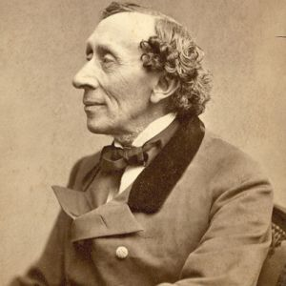
https://www.biography.com/people/hans-christian-andersen-9184146

https://www.google.com/search?q=hans+christian+andersen+books&ie=UTF-8&oe=UTF-8&hl=en-us&client=safari&scrlybrkr=fd30e1e1

https://www.merriam-webster.com/dictionary/romanticism

http://www.andersen.sdu.dk/vaerk/hersholt/TheLittleMatchGirl_e.html
http://www.imdb.com/name/nm0026153/?scrlybrkr=3687802f

