The White Heron by: Sarah Orne Jewett
Biography Info Sheet

a. most important life events that influenced his/her work and writing career
~When Jewett was young, her father took her with him on business trips since he was a doctor. In her home state Maine, she was able to be immersed in the way of life of fishers and farmers that her father worked for. She learned to love there way of life, and began writing works about the perishing farms and harbors around her.

b. time period of writing—which literary movement is the writer a part of? What are the characteristics of that movement? (Ex. Romanticism, Naturalism, Realism, Modernism, Post-Modernism)
~Sarah Orne Jewett was a part of the local colour moment. The characteristics of local colour is regionalism and realism. Local colour focused on the characters, dialect, mannerisms, and customs specific to a particular region.

c. What is his or her style like?
~She wrote three novels and said that narrative was not her style. She also wrote books designed for children. However, Sarah wrote many short stories or vignettes. Short stories was more of Sarah’s style of writing.

d. the author’s impacts on the literary field and/or society
~She was an important local-color writer because she loved to write about the culture, dialect, and history of her hometown. These types of literary works, also called literary regionalism, helped to preserve regional identities after the Civil War.

e. any interesting facts about the person and his/her work in general or the particular short story in particular
~She traveled with her father on his doctor runs which broadened her creative mind. She spent so much time with her father that she learned to truly adore him. This sounds sweet and all, but it actually prevented her from having a love life of her own. She never married later in life.
~She was hurt in a carriage accident in 1902 which ended her writing career and had a stroke that paralyzed her in 1909. A few months later, she died.

f. a picture
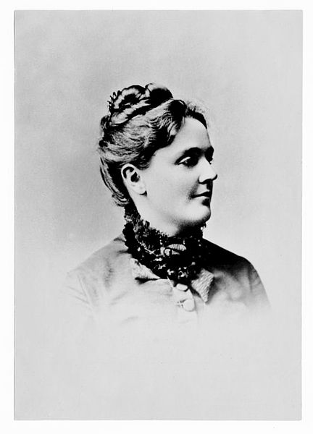

g. links at the bottom that cover all the information in the piece
a~ https://www.britannica.com/biography/Sarah-Orne-Jewett

b~https://public.wsu.edu/~campbelld/amlit/lcolor.html

c~https://www.britannica.com/biography/Sarah-Orne-Jewett

d~ https://en.m.wikipedia.org/wiki/American_literary_regionalism?scrlybrkr=9eaac005

~ https://www.britannica.com/biography/Sarah-Orne-Jewett

e~ http://biography.yourdictionary.com/sarah-orne-jewett

~ https://en.m.wikipedia.org/wiki/Sarah_Orne_Jewett?scrlybrkr=9eaac005
f~ https://assets.americanliterature.com/al/images/author/sarah-orne-jewett.jpeg

