O. Henry’s Biography
- Some important life events that affected O. Henry’s life was his mother's death which is represented as loss seen in the short story “The Cactus”. In the short story he is confused why he no longer has the girl which could relate to his mom dying when he was a young child which could also have lead to confusion. He also lived in many new places including NC, NYC, and Honduras.
- There were many literary movements going on in O. Henry’s time, but the main one Henry focused on was realism. Realism is the attitude or practice of accepting a situation as it is and being prepared to deal with it accordingly. O. Henry uses normal, real life situations and the key to their impact. Most of his stories, such as “The Furnished Room”, face harsh realities of the real world like sadness, loneliness, or disappointment. Another famous author whose style of writing was realism was Gustave Flaubert. He the wrote the famous story “Madame Bovary” in 1857.
- O. Henry’s style of writing is often dry or humorous. In his story “The Gift of the Magi” he often ironically uses coincidences and surprise endings. Most of his stories are often fictional. With Henry’s normal life situations he make the reading feel legitimate and informed.
- A fun fact about O. Henry’s that’s not even his real name. His real name is William Sydney Porter, and O. Henry is his pseudonym. Henry’s wife of 10 years died of tuberculosis. Shortly after he was imprisoned in Ohio for embezzlement.
- O. Henry’s work was known for its plot twists which is very influential to today's works and movies. Without the twists there wouldn't be the same amount of suspense therefore creating interesting literature stories and movies now. 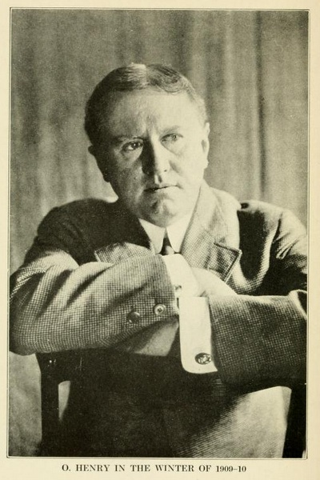

https://americanliterature.com/author/o-henry
http://northcarolinahistory.org/encyclopedia/o-henry-1862-1910/
https://www.biography.com/people/william-sydney-porter-9542046
https://study.com/academy/lesson/o-henry-writing-style-technique.html
http://www.online-literature.com/periods/timeline.php

