Charlotte Perkins Gilman

1. The event that mostly influenced Charlotte Gilman’s story, “The Yellow Wallpaper”, is that she suffered a very serious bout of post-partum depression. She visited a specialist in nervous diseases who told her she basically had nothing wrong with her. He applied the rest cure which says to live a very domestic life and told her to never touch a pencil, pen, or brush for as long as she lives. She followed instructions for as long as she could until she couldn’t anymore and that’s when she wrote The Yellow Wallpaper.
2. The time period of writing that Charlotte Gilman was a part of was a mix of Romanticism and naturalism. She wrote stories that expressed the writers emotion or inner world. She also idealized woman in her writing. She wrote stories about her opposition of free will and Determinism with the character.
3. Charlotte Gliman’s writing style was influenced by her feminist viewpoint. She uses symbolism in her works to create a sense of wonder and to keep readers engaged until the end of the story. She doesn’t make the conclusions to her stories very transparent either which leaves some parts of the story up to your interpretation. She uses women as the main characters and they develop as the story goes along.
4. She had a had a profound effect on the development of the American society as we live and understand it today. Her view on feminism has served as a catalyst for others to grasp hold of to empower them for change. Allowing them the rights they have now.
5. Charlotte in her later years suffered from terminal breast cancer and moved back home to live with her daughter. However unable to dies a painful death she committed suicide with chloroform. A great thought she had is that the progression of humankind is at a halt till you allow for women to acquire autonomy and let them live their lives to their full capacity. Also she accepted gynecocentric point of view that saw female as the dominant species and men’s only purpose is to assist in fertilization.
6. 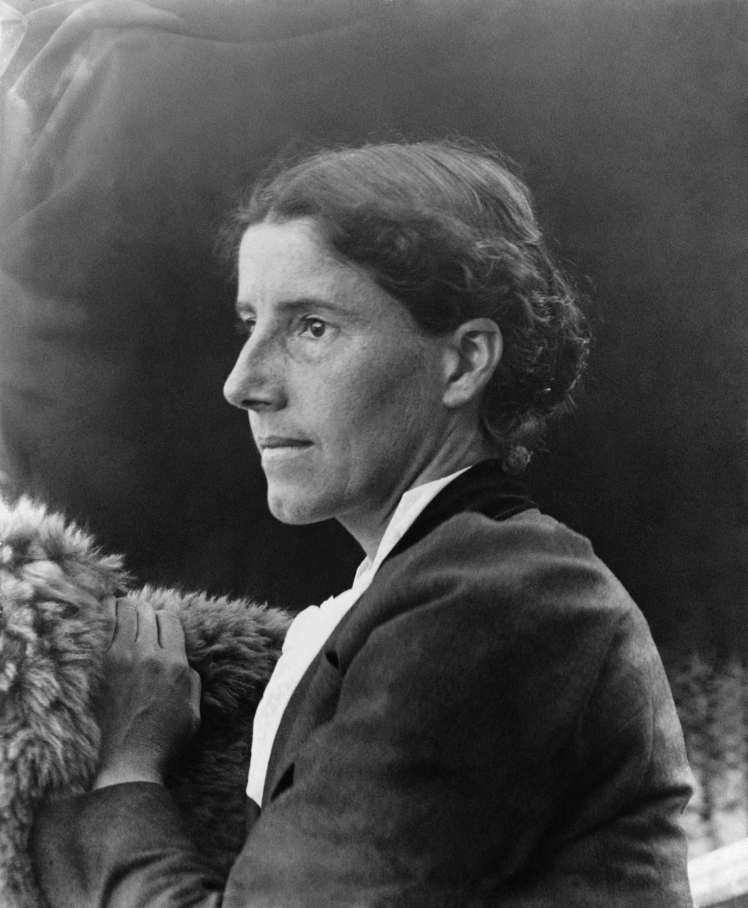

G. Links

<https://edsitement.neh.gov/lesson-plan/charlotte-perkins-gilmans-yellow-wall-paper-writing-women>

<https://en.m.wikipedia.org/wiki/Naturalism_(literature)?scrlybrkr=4995f492>

<https://public.wsu.edu/~campbelld/amlit/natural.htm>

<https://www.enotes.com/homework-help/what-clue-narrators-repeated-lament-what-can-one-1211114>

<http://biography.yourdictionary.com/charlotte-anna-perkins-gilman>

<https://www.encyclopedia.com/people/social-sciences-and-law/social-reformers/charlotte-perkins-gilman>