Semicolons on the SAT
The only thing you have to know about semicolons is that they are used to separate two complete thoughts. You should be able to replace the semicolon with a period and have two complete sentences. Here’s an example:
Incorrect: Because Jesse is my friend; I invited him to my party.
Correct: Jesse is my friend; I invited him to my party.
The second sentence is correct because the semicolon is separating two independent clauses. On the SAT, semicolons are often used incorrectly.

SAT Example
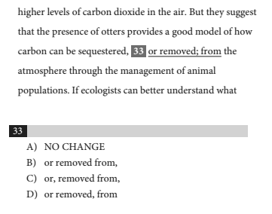
Immediately, we know that the semicolon is incorrect because the phrase after the semicolon can’t stand alone as a sentence. Now we have to determine the correct comma placement. Answer choices B and C are wrong because you can’t place a comma after a preposition. Answer choice D is correct; the comma separates the independent clause from the explanatory phrase. Keep in mind that commas often separate independent clauses from dependent clauses or descriptive phrases.

Colons on the SAT
Colons can connect two independent clauses, but they're usually used to introduce lists and explanations. Colons must come after a complete sentence. You should be able to put a period in place of the colon and have a sentence that makes sense.
Incorrect: Jasmine brought everything she needed for the exam, including: pencils, a backpack, and a calculator.
Correct: Jasmine brought everything she needed for the exam: pencils, a backpack, and a calculator.
The first sentence is incorrect because the part that comes before the colon isn’t a complete thought.
Also, a colon should be used instead of a comma to separate a noun from items on a list:
Incorrect: Lewis was excited to meet his relatives, his aunt, uncle, and cousins from the Bahamas.
Correct: Lewis was excited to meet his relatives: his aunt, uncle, and cousins from the Bahamas.
The first sentence makes it seem like “his relatives” is part of the list. However, all of the people he is meeting are his relatives, and the portion after the colon lists the relatives whom he will be meeting.
Additionally, colons can be used to provide explanation. Here’s an example:
Sandy repeatedly complained about her least favorite restaurants: places where you can often hear loud conversations and crying babies.

In the above sentence, the colon is placed after a complete thought, and the portion of the sentence after the colon describes the type of restaurants that Sandy dislikes. You could substitute the colon with a comma, but you need punctuation to separate the complete thought from the explanatory phrase.

SAT Example
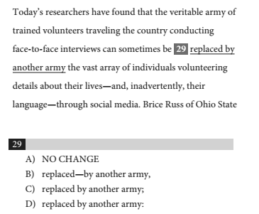
The portion of the sentence after “army” describes the other type of army. We need punctuation to separate the complete thought up until “army” from the phrase elaborating on this group of people. Answer choice C is incorrect because the phrase following “army” isn’t a complete thought, and answer choice B is wrong because the dash before “by” is unnecessary (I’ll explain dashes next). The correct answer is D.

Dashes on the SAT
Dashes aren’t very common on the SAT, but they do come up. They can be used to mark off a non-essential clause or phrase (like a comma) or introduce a list or explanation (like a colon).
If dashes are used with non-essential clauses or phrases, you can’t mix them with commas. You have to go with either two dashes or two commas. Here’s an example:
Incorrect: Ryan, an energetic teenager—can’t sit still during class.
Correct: Ryan—an energetic teenager—can’t sit still during class.
Correct: Ryan, an energetic teenager, can’t sit still during class.
This is an example using a dash like a colon to set up an explanation:
Correct: Ryan can’t sit still during class—he’s an energetic teenager.
Lastly, a dash can be used for stylistic reasons to interrupt a statement or create a dramatic pause. Check out this example:
Byron spent hours painting a beautiful picture—and then his little brother destroyed it.
You don’t have to worry too much about using dashes for this type of sentence. If a dash is the correct answer in a similar sentence, then you’ll be able to eliminate the other answer choices because they’ll be obviously incorrect.

SAT Example
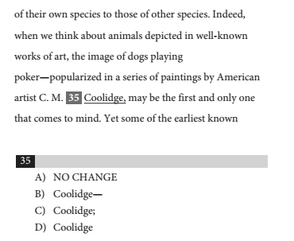
The phrase from “popularized” to “Coolidge” is a non-essential phrase. You can get rid of the phrase without altering the meaning of the sentence. The error is that the phrase is first marked off with a dash and then a comma. Remember that you can’t mix dashes and commas when marking off non-essential phrases and clauses. Therefore, to maintain consistency, the correct answer is B.

From http://blog.prepscholar.com/sat-punctuation

