Roald Dahl
Influences:
Roald Dahl had many influential events in his life such as his schooling, service as a fighter pilot in World War II, and raising his children. All of these events greatly affected his work and writing career. Dahl’s experiences at the boarding schools he attended gave him inspiration for his later works Charlie and the Chocolate Factory, Matilda, and Boy. At boarding school, Dahl hated rules and experienced harsh punishments for disobeying them. This distaste for rules and authority manifested itself later in his works when he punishes the cruel adults in his stories. Also, while at one of the boarding schools he attended, students were allowed to try chocolate bars which influenced his book Charlie and the Chocolate Factory. Another event that influenced Dahl’s work and launched his writing career was his service in the Royal Air Force. Dahl’s experiences as a fighter pilot helped him to write his book The Gremlins. This can be seen in that Gremlins were small creatures that caused planes to crash and Dahl had been in a plane crash before becoming a writer. Even the ordinary occurrence of telling stories to his children before bed helped Dahl to become a more engaging writer as he was forced to tell stories that kept his young children’s attention.

Literary Movement:
The literary movement Roald Dahl was a part of was Postmodernism. Postmodernism can be characterized by its denial of objective morality, high emphasis on relativism, disdain for traditional authority, and liberal political stance. Dahl’s postmodern views can be seen in his heroes and heroines whom the reader is left to decide how they view them. Due to the postmodern nature of his works which do not tell the reader what to think and the wide variety of ages he has written for, Dahl is one of the most well read and recognizable authors of all time.

Style:
Dahl’s style incorporates unexpected twists and turns as well as the use of deception to keep the reader engaged. He possesses a unique writing style that is humorous, odd, and sometimes frightening. Dahl is very skilled at using his literary devices and playful language in order to convey a certain picture. His interesting and wacky sense of humor can be seen in his book James and the Giant Peach where the protagonist, James, travels inside of a large peach of New York City. Dahl is especially well known for his use of “black humor” which makes light of serious topics.

Influence on Society:
Roald Dahl’s influence on society was that he composed many stories that have become very well known today and many of which have been turned into very famous movies. Two examples of his stories that were turned into movies that many people know are Charlie and the Chocolate Factory and Fantastic Mr. Fox. Another impact he had on the literary field and society was that because of all the really famous stories he composed, many people today consider him to be the world’s greatest storyteller of all time.

Interesting Facts:
An interesting fact about Roald Dahl was that when he was young, both his sister, Astri, and his dad died. After they died, Dahl’s mom sent him to boarding school where he and the other pupils were able to test different chocolate bars. This experience at boarding school is what inspired Dahl to write the story Charlie and the Chocolate Factory.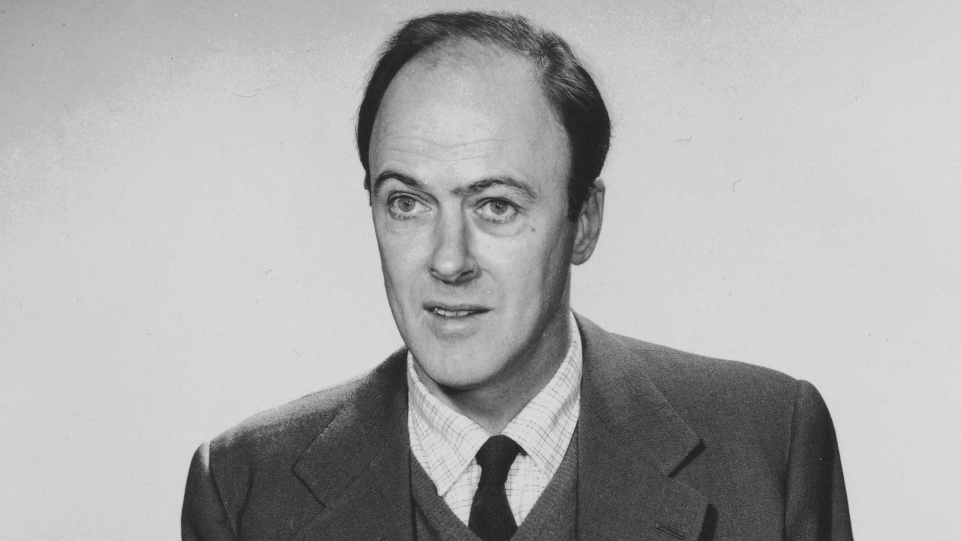

http://www.chameleoncorporation.com/2013/10/03/roald-dahl-style-of-writting/
https://www.enotes.com/homework-help/writing-style-roald-dahl-stories-children-263141
https://www.roalddahl.com/roald-dahl/about
http://www.notablebiographies.com/Co-Da/Dahl-Roald.html
https://www.allaboutphilosophy.org/characteristics-of-postmodernism-faq.htm
https://www.roalddahl.com/roald-dahl/about
http://www.roalddahl.com/roald-dahl/timeline/1970s

